Excel Assignment 2 – Data Exploration
● Duplicate Removal Process
In case any duplicates found, go to DATA tab then “REMOVE DUPLICATES “.
This is given in below images.
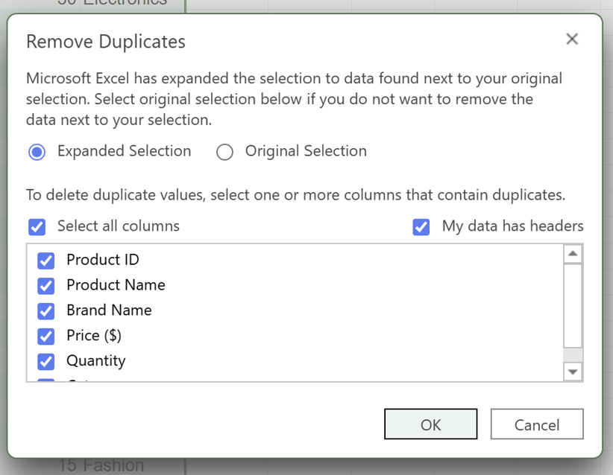
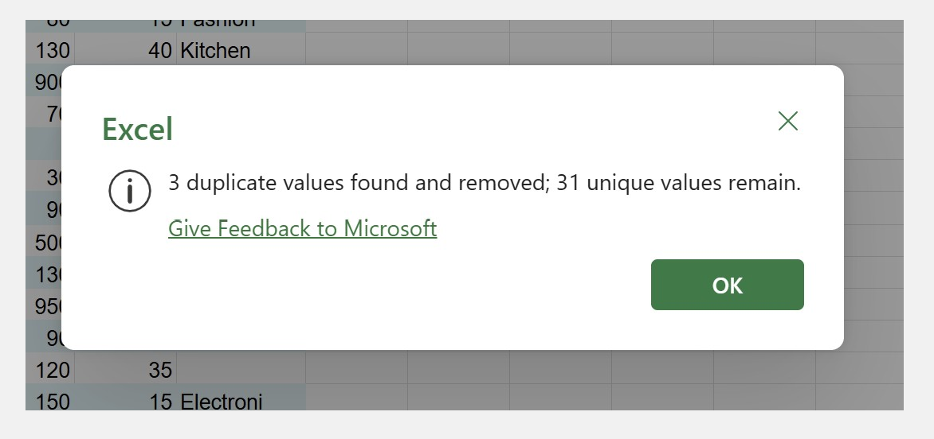

● Find and Replace Corrections
To find and replace any corrections, go to HOME tab then “FIND AND REPLACE”
Give the incorrect format in find and the correct one in replace and give REPLACE ALL as shown in below image.
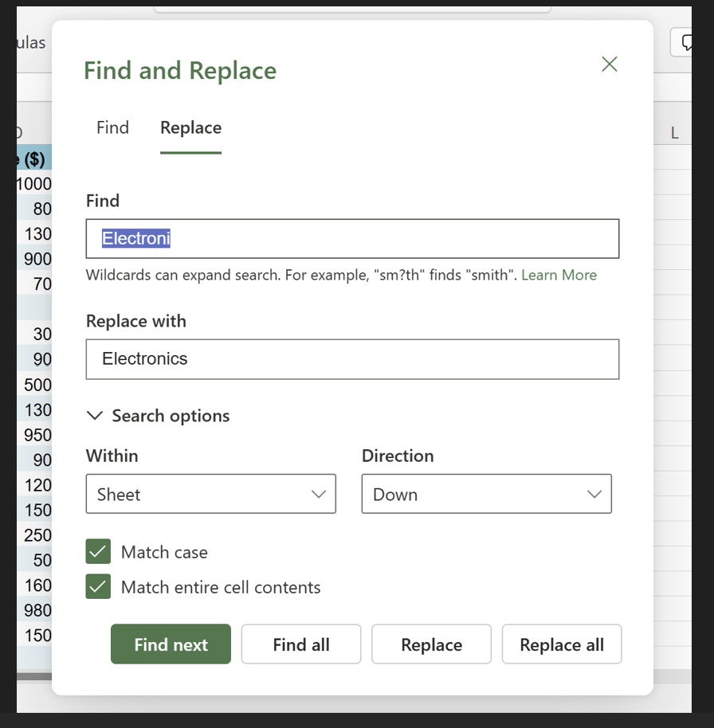
● Column Splitting and Merging
- Product ID is split into two columns using ”LEFT”(Manufacturing Date) and ”RIGHT”(Country Code) functions as given below
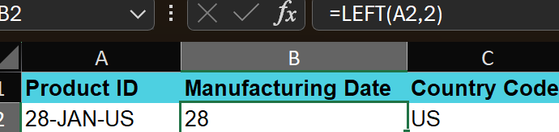
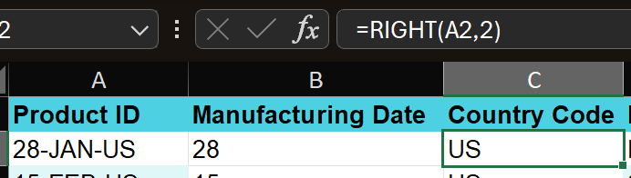
- Product Name and Brand Name is merged into one column Product Brand using “CONCATENATE Function”
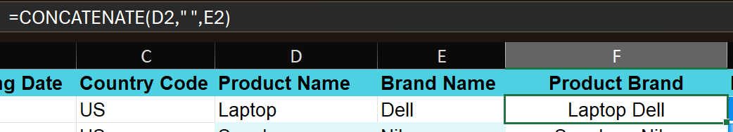
● Correcting Inconsistent Data
Inconsistent data is corrected using “PROPER” Function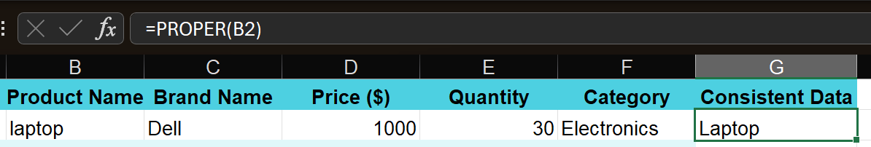

● Missing Value Handling
In case of missing values, imputation needs to be performed. Here the column is Price (Numerical), so “Average” should be taken here for imputation.
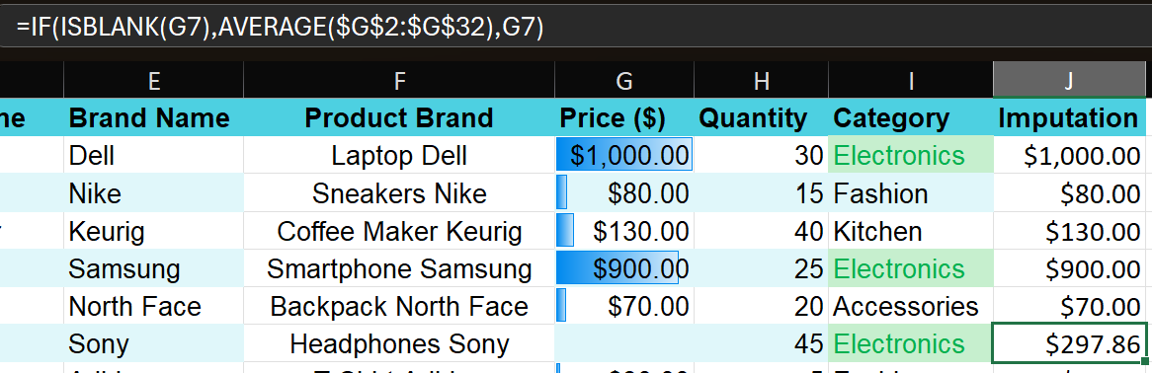
For missing values in Category column(Categorical), either “UNKNOWN” or “NA” can be provided.
●Number Formatting
- To format the datatype of Price, the given below steps are followed.
In Home tab, change the datatype from General to CURRENCY and decimal values can also be customised.
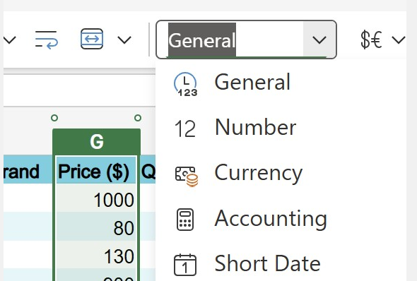
- To change the date format in Manufacturing Date, the below formula is used and then give CUSTOM as DD-MM-YYYY in number formatting

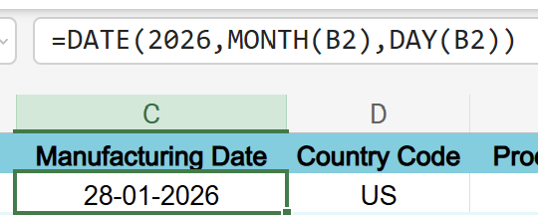
● Conditional Formatting
- In Price column, DATA BAR is given as below,
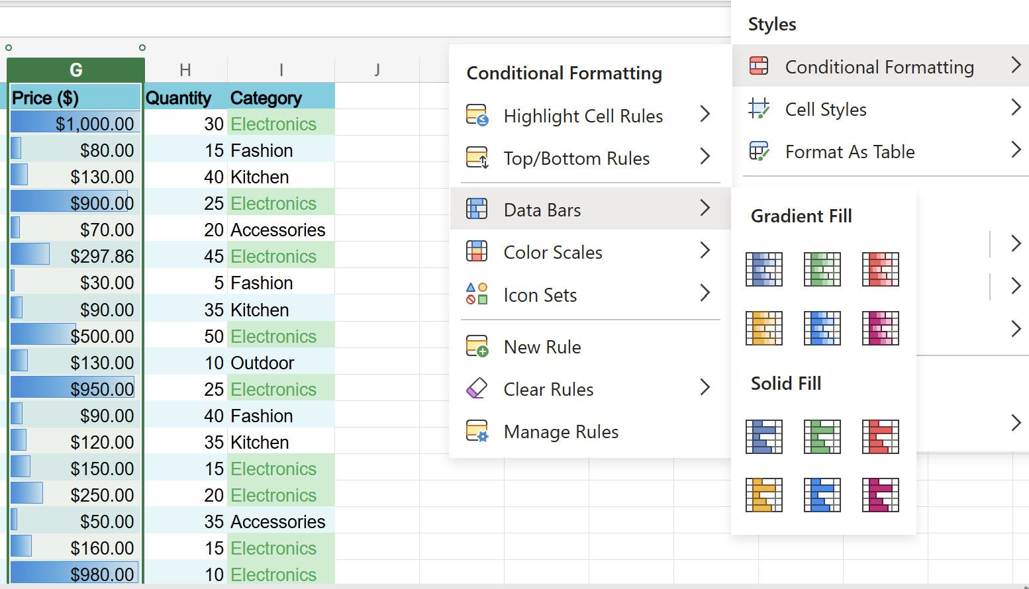

- Custom rule is created here for HIGHLIGHTING CELLS with ELECTRONICS as category.
